Data Prep

While Validating keeps the “VBA Macros Script” Excel file open in the background to fetch the script in Bulksheet.
Copy the data from the ATP File
- Create a tab in the Bulksheet and rename it. Do the naming in the format ex. ATP – Keywords
- Repeat the above steps for each tab that needs to be moved or copied to the bulk sheet.

Tab Name while adding the data from the ATP File
    - ATP-RSAs
    - ATP-Keywords
    - ATP-Ad Extensions
    - URLs
    - Landing Pages

RSA data
Validating RSAs Data
- Change the Headline Position and Description Position format In ATP – RSAs Tab from text to number. (In workbooks rarely, it seems to be present in the text format).
- Can use the following method for this conversion.
- Enter the number 1 in any empty cell.
- Copy this cell (Ctrl + C).
- Select the cells/Columns with the numbers stored as text. (Headline position/Description Position column)
- Right-click on the selected cells and choose "Paste Special."
- In the Paste Special dialog box, select "Multiply" and click "OK."
- This will convert the text to numbers.
- Create a Concatenation column in ATP-RSAs (it’s better to type on the place of copy-pasting from here)
- For RSAs Headline --> Concatenate Campaign/Ad Group/Headline/Headline Position
- For RSAs Description --> Concatenate Description/Description Position
- Note --> Doesn’t need to be in a specific column of the ATP file.
- While working check for the below prerequisites in the ATP File -->>
- Campaign data is present in Column "A"
- Ad Group data present in Column "B"
- Headline Option in Column "C"
- Headline Position in Column "E"
- Description in Column "F"
- Description Position in Column "H"

- While executing -->> Execute all the scripts in alphabetical order.
- Open the tab on which validation needs to be done. (Google RSAs/Bing RSAs)
- Click Automate in ribbon à Macros à Execute A_RSAs_Validation.
- Repeat the same scripts for Google & Bing Tab.
- Manually Validate the data present in the display URLs column with ATP File.

Keyword data
Validate Keywords data
- Open the tab on which validation needs to be done. (Google Keywords/Bing Keywords)
- Click Automate in ribbon à Macros à Execute the “B_Keywords_Validation” VBA script for validation.
- Repeat the same scripts for Google & Bing Tab.
- Prerequisites for data in ATP File
- Ad Group data present in Column "B"
- Keyword data present in Column "C"
- Destination URL present in Column "E"

Callout/Snippet data
Validate Callout/Callout Extension and Structure Snippet
- In the Callout/Structure snippet tab make sure the “Callout Text column”/” Structure Snippet Column” (on which testing needs to be done) should start with index 1 (Column header 1). Or can simply delete the “Google & Bing” Headline.
Refer to the screenshot below (Applies to both Callout/Structure snippets)
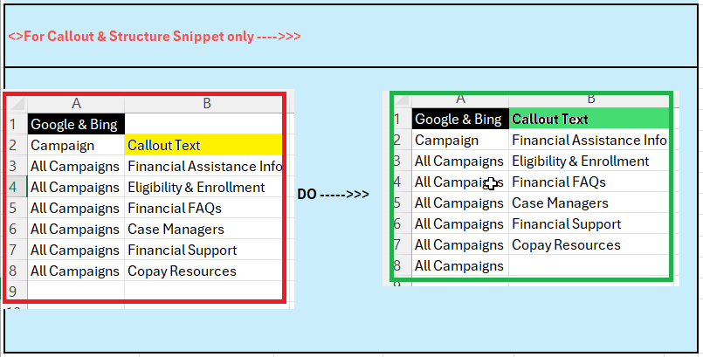

- Click Automate in ribbon à Macros à Execute the “C_CalloutText” script for Callout validation and “D_StructureSnippet” script for Structure Snippet validation.

Sitelink data
Validate Sitelink
- Make sure the column name starts from index 1. (You can refer to the screenshot in validate callout/structure snippet)
- Execute the “E_Sitelink_Validation” script to validate the Sitelink data.

Action Extension data
Validate Action Extensions
- Execute “F_ActionExtensions” script to validate the Action extensions.

URL data

Keywords, Sitelink & Action Extension
Validate URLs
- Add clean URLs from Google/Bing (Keywords, Sitelink & Action Extension) tabs in the “URLs Tab” and remove the duplicates.
- Execute the “G_ValidateURLsFunctionality_Jenkins” (This will validate the functionality of URLs (can replace Jenkins)) and print the status of URLs.
- Execute the “H_Vlookup_DestinationURLs_With_LandingPages,” it VLOOKUP the URLs with the URL data in Landing Pages.

Landing Pages
Validate Landing Pages
- Prerequisite The landing pages column should be in column “A” and the tab name should be “Landing Pages”
- Execute “G_ValidateURLsFunctionality_Jenkins” to validate Landing Pages functionality.

Manual check -Tactic Code/Call-Extensions
Validate Manually
- Validate the Data in the “Tactic code Tab” on Gcampaign Manually
- Manually Validate the data present in the “Display URLs” column with ATP File
- Manually need to validate the tactic code present in the Gcampaign tab are present across the Bulksheet.
- If the “Call-Extensions” data are present in the Bulksheet then need to validate manually.

Future state/Discovery
Approach 2 Validating RSAs Data (Currently WIP)
- Create a tab in the Bulksheet and rename it. Do the naming in the format ex. ATP – RSAs.
- Arrange the columns à Remove excessive data from copied ATP File (Refer to Screenshot 1) in the ATP file, so that the header becomes index 1 (Refer to Screenshot 2).

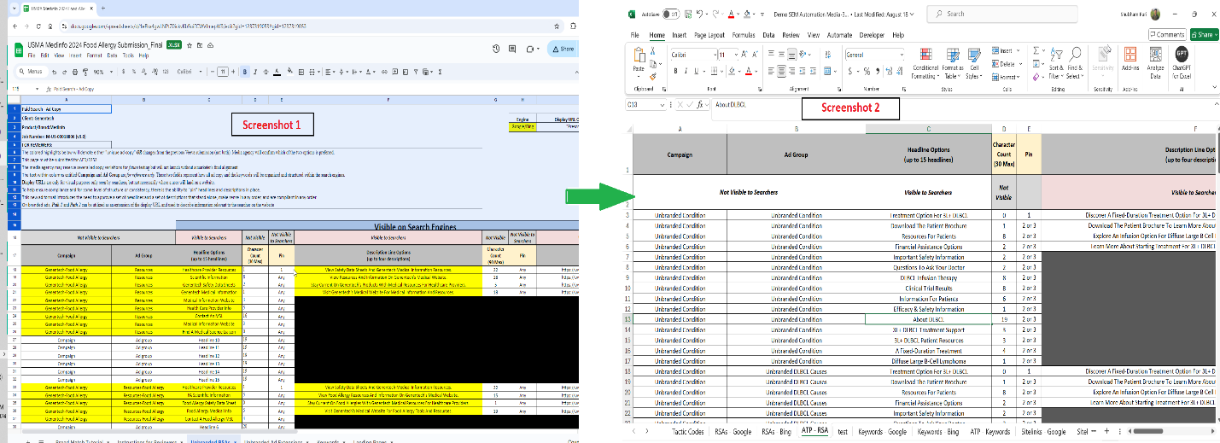

- While working check for the below prerequisites in the ATP File -->>
- Campaign data is present in Column "A"
- Ad Group data present in Column "B"
- Headline Option in Column "C"
- Headline Position in Column "E"
- Description in Column "F"
- Description Position in Column "H"
- Click Automate in ribbon à Macros à Execute A_RSAs_Validation.
- Manually Validate the data present in the display URLs column with ATP File.
- Validate the Data in the “Tactic code Tab” on Gcampaign Manually.

Validating the Display URLs (Currently WIP)
- Execute the “z_ValidateDisplyURLs” (Module24).

